Data Management – Activity 2 (Marked 5%)

Ethical Theories and AI
- Can you identify any of the ethical theories that we covered in class in the excerpt from Anthropic’s constitution for Claude, and why?
- What wording or principle support that that conclusion? Cite lines or phrases from the excerpt.
- Considering the critiques of the ethical theories that we have discussed in class can you think of a critique of the ethical perspective that you identify in the Claude constitution (at leased based on the excerpt below)
- What do you think about this idea of companies such as Anthropic attempting to imbue value-based ethics to AI models rather than relying on rule-based frameworks? Outline both opportunities and risks.
Make sure to use academic citations and referencing.
If you use GenAI for parts of the activity include a description of the model and the prompts that you used and how it helped you complete the activity.
Submit to Brightspace
Submit your answers (approximately 1 paragraph for each question) as a PDF to Brightspace by Thursday 12th February 23:30 (full-time) and Sunday 15th February 23:30 (part-time).

References

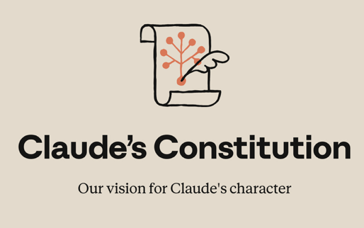
We’re publishing a new constitution for our AI model, Claude. It’s a detailed description of Anthropic’s vision for Claude’s values and behavior; a holistic document that explains the context in which Claude operates and the kind of entity we would like Claude to be. The constitution is a crucial part of our model training process, and its content directly shapes Claude’s behavior. Training models is a difficult task, and Claude’s outputs might not always adhere to the constitution’s ideals. But we think that the way the new constitution is written—with a thorough explanation of our intentions and the reasons behind them—makes it more likely to cultivate good values during training.

What is Claude’s Constitution?
Claude’s constitution is the foundational document that both expresses and shapes who Claude is. It contains detailed explanations of the values we would like Claude to embody and the reasons why. In it, we explain what we think it means for Claude to be helpful while remaining broadly safe, ethical, and compliant with our guidelines. The constitution gives Claude information about its situation and offers advice for how to deal with difficult situations and tradeoffs, like balancing honesty with compassion and the protection of sensitive information. Although it might sound surprising, the constitution is written primarily for Claude. It is intended to give Claude the knowledge and understanding it needs to act well in the world.

A brief summary of the new constitution
In order to be both safe and beneficial, we want all current Claude models to be:
- Broadly safe: not undermining appropriate human mechanisms to oversee AI during the current phase of development;
- Broadly ethical: being honest, acting according to good values, and avoiding actions that are inappropriate, dangerous, or harmful;
- Compliant with Anthropic’s guidelines: acting in accordance with more specific guidelines from Anthropic where relevant;
- Genuinely helpful: benefiting the operators and users they interact with.
Claude’s ethics. Our central aim is for Claude to be a good, wise, and virtuous agent, exhibiting skill, judgment, nuance, and sensitivity in handling real-world decision-making, including in the context of moral uncertainty and disagreement. In this section, we discuss the high standards of honesty we want Claude to hold, and the nuanced reasoning we want Claude to use in weighing the values at stake when avoiding harm. We also discuss our current list of hard constraints on Claude’s behavior—for example, that Claude should never provide significant uplift to a bioweapons attack.
Full constitution available https://www.anthropic.com/constitution

